Q1- Create dashboard with given requirements.

1-Total discount, quantity, profit and sales in KPI format

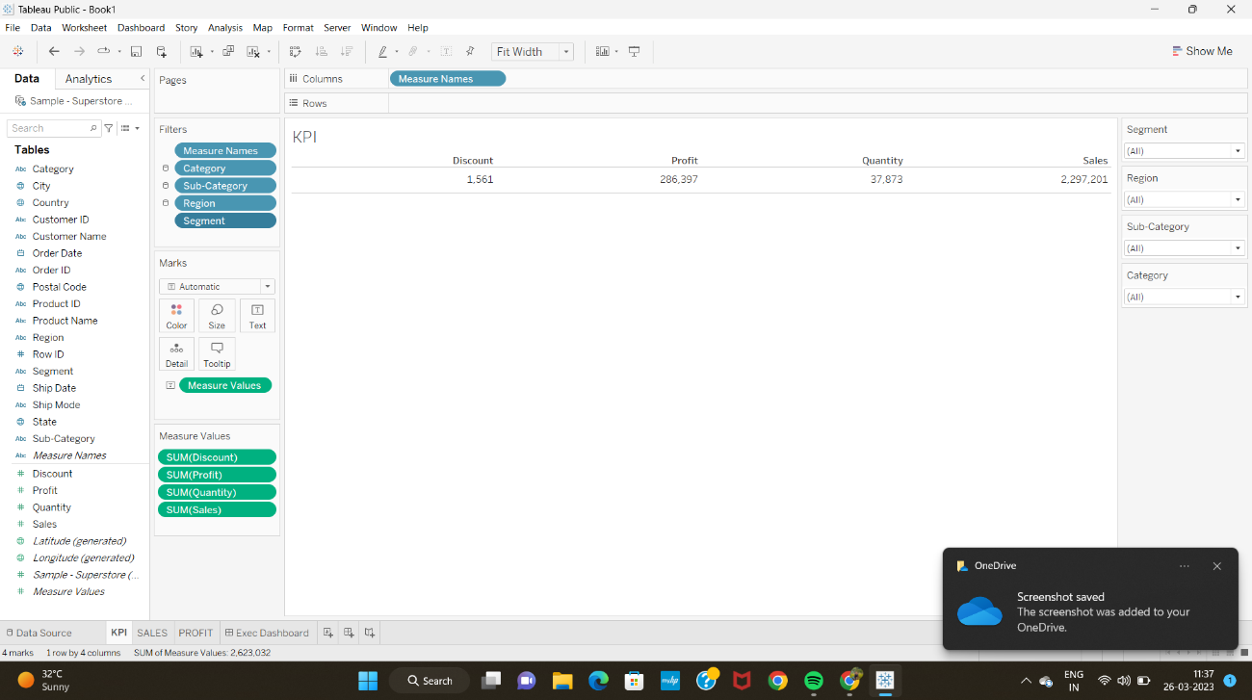

2-Shows monthly sales per year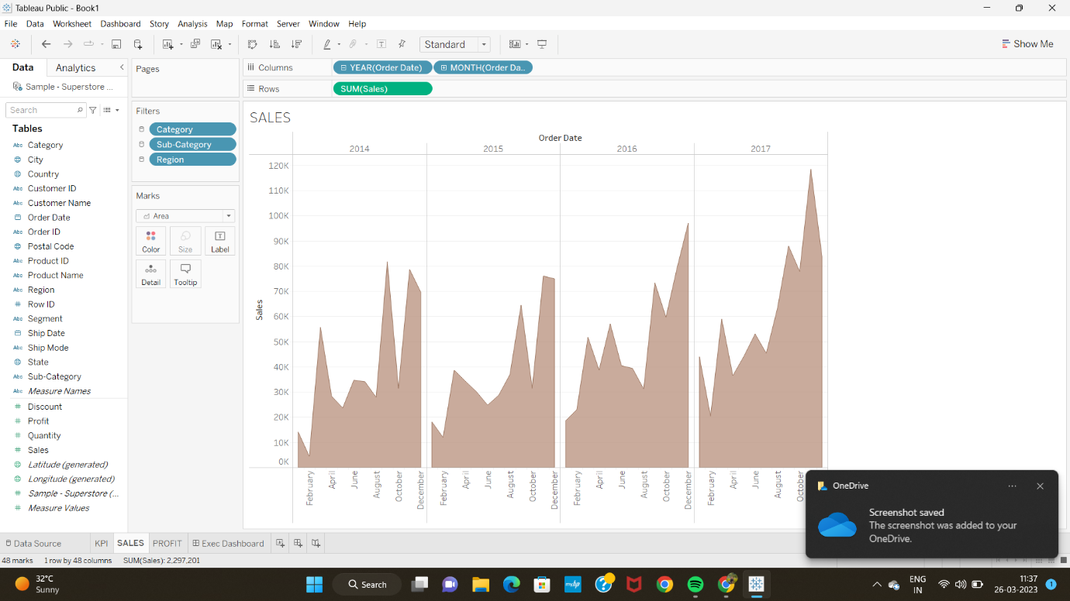

3- Shows monthly profit per year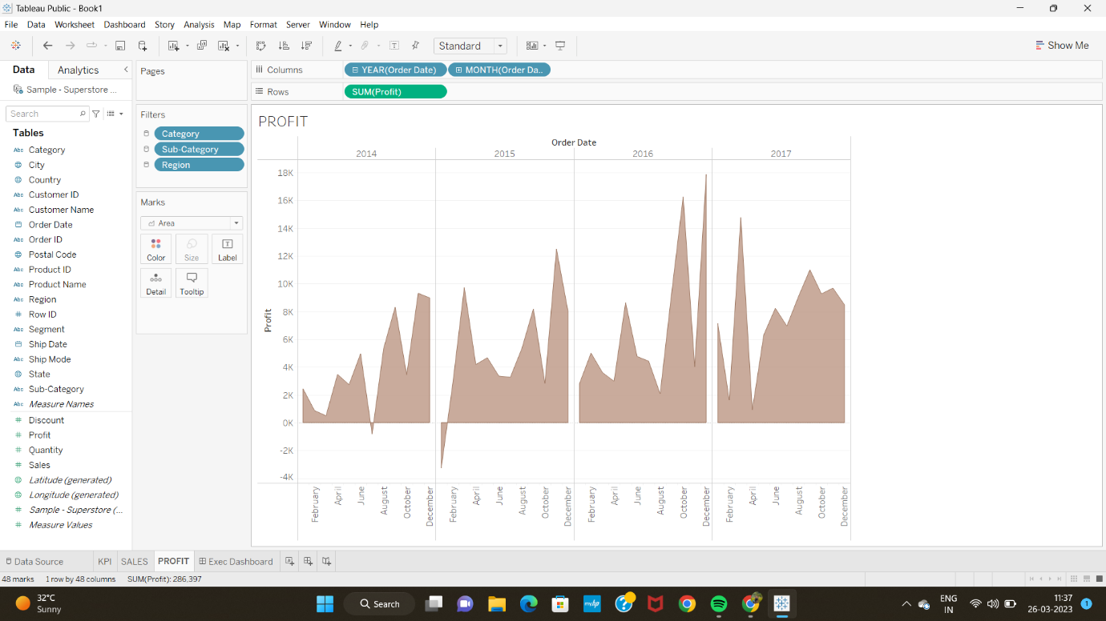

DASHBOARD CREATED:-

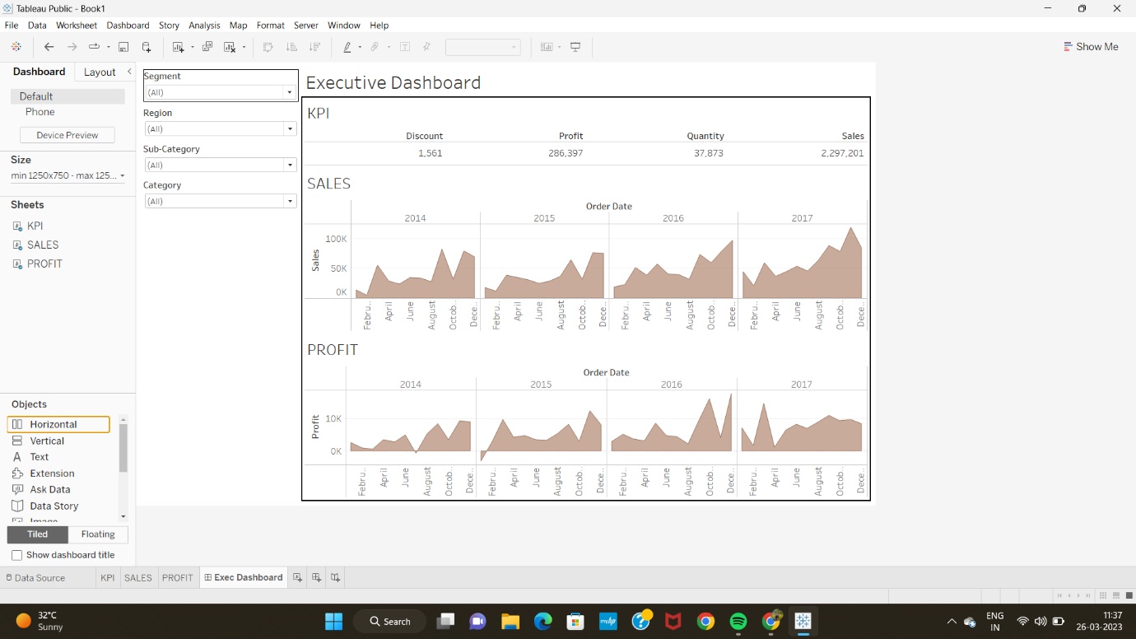

Q2-

1. Top 5 cities which bear maximum loss?

Answer- Philadelphia (-13,838)

Houston (- 10,154)

San Antonio (-7299)

Lancaster (- 7239)

Chicago (-6655) 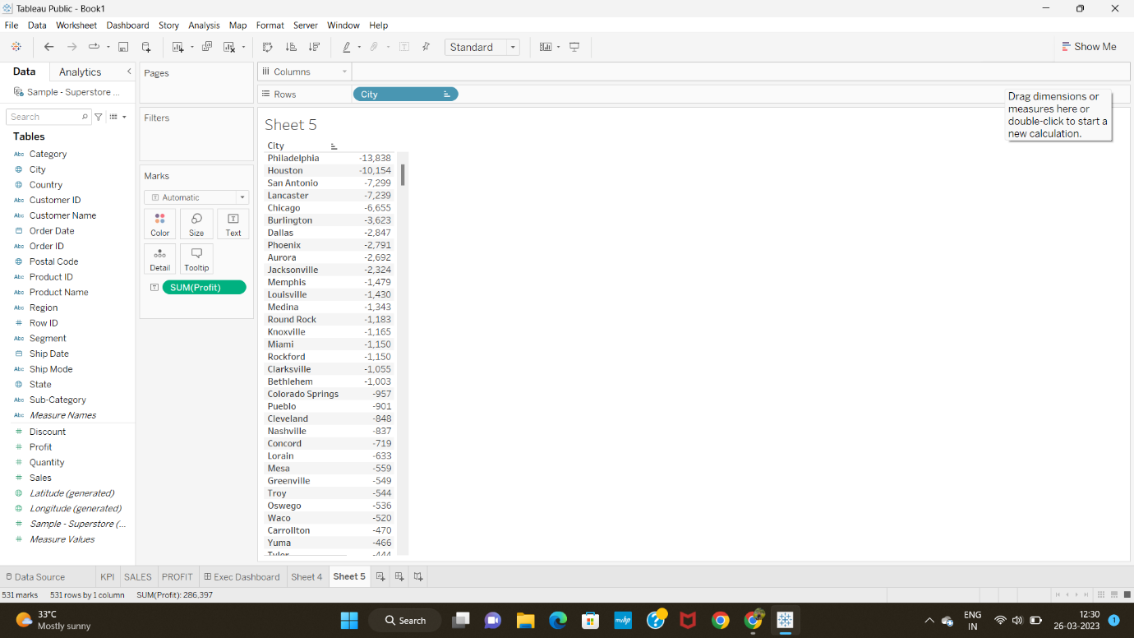

1. Which is the region with highest sales?

Answer= West region

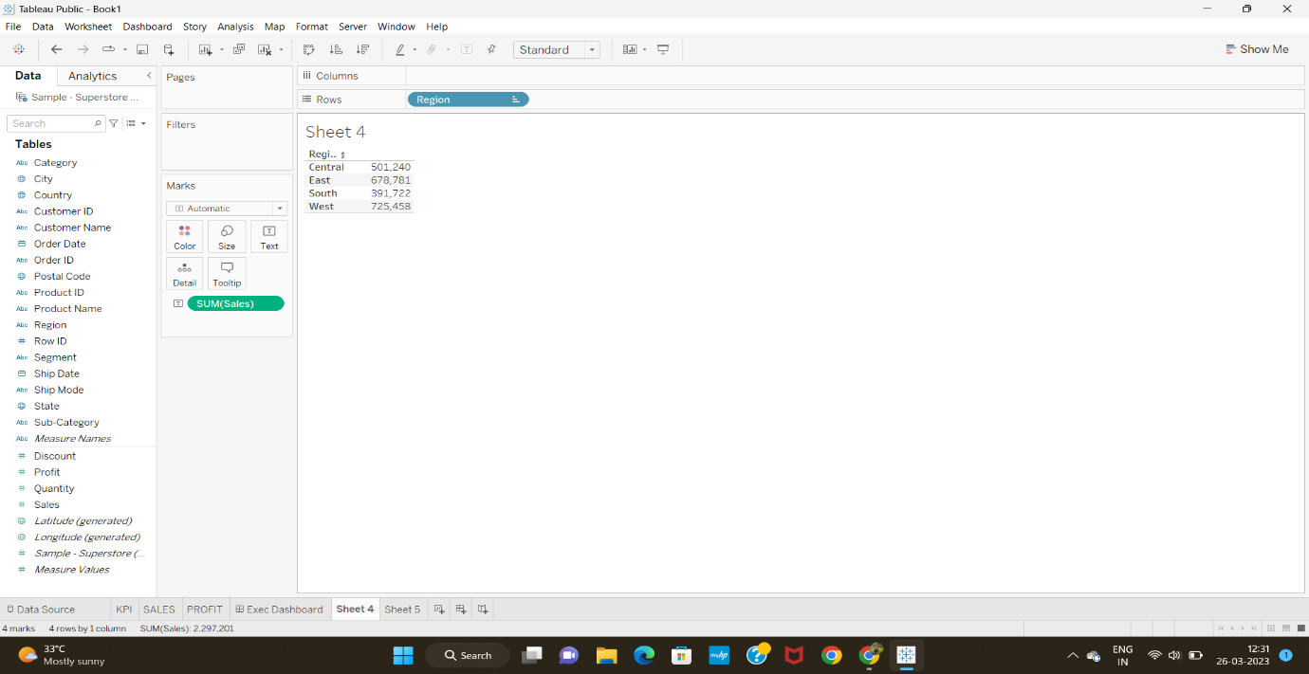

3-Name category in region with highest sales?

Answer= Central- Chairs (85231)

East- Phones (100615)

South- Phones (58304)

West- Chairs (101781)

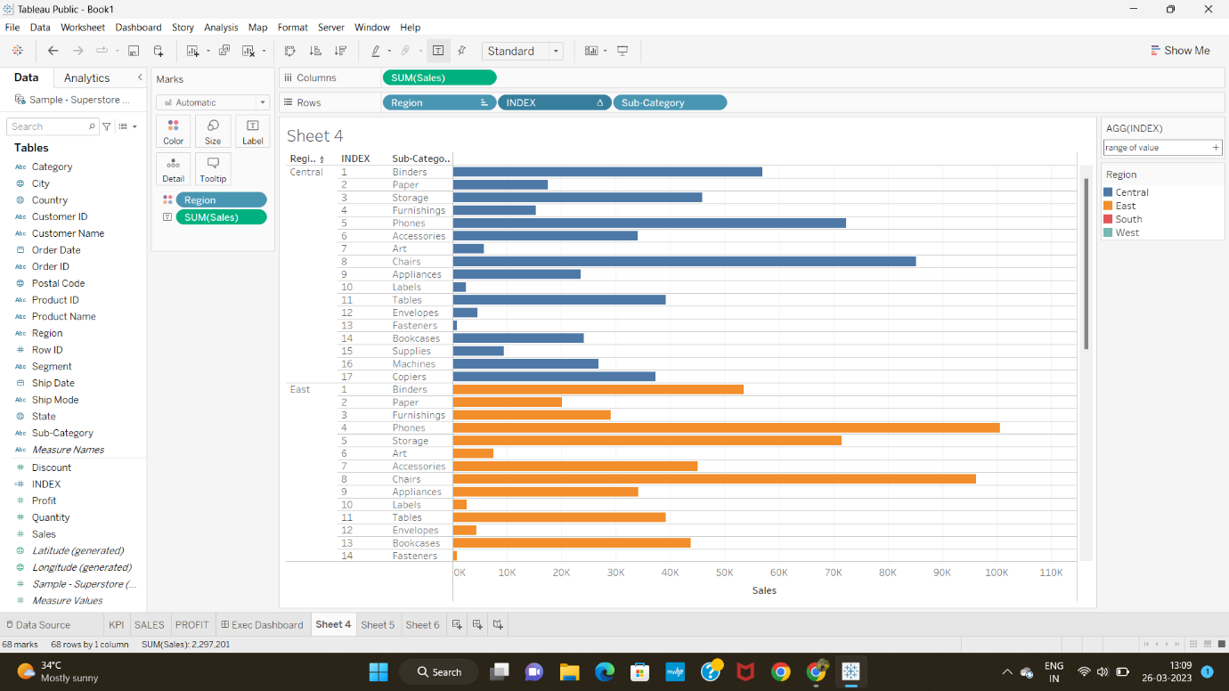

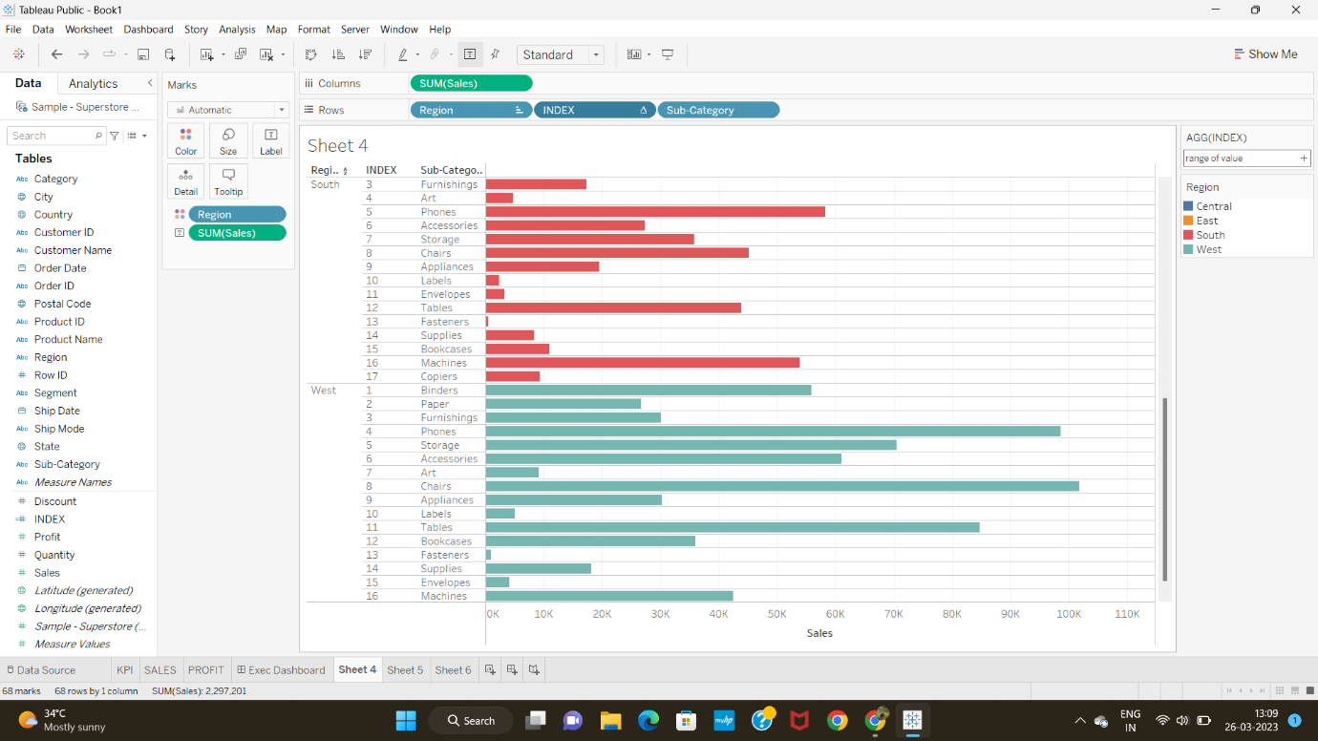

4-Which state has highest quantity of orders?

Answer= California

